VocalAid

Dysarthria Speech Therapy Assistant



FYP Team

Ms. Areeb Dastgeer 22F-3099
Ms. Hamna Alim 22F-3166
Ms. Hamyal Naveed 22F-3184

Supervisor: Dr. Tahir Farooq

Co-Supervisors:

Dr. Muhammad Usama
Mr. Asif Ameer

Department of Artificial Intelligence and Data Science
National University of Computer and Emerging Science
Chiniot – Faisalabad Campus, Pakistan
2026

Intellectual Property Rights Declaration
This is to declare that the above publication was produced under the:
Title: VocalAid
BS FYP MS Research Survey MS Thesis Course Project
Is the sole property of the National University of Computer and Emerging Science and is subject to intellectual property right laws. It can only be utilized/considered for use such as intention for further development, product development, adoption for commercial/organizational purposes, etc., with the permission of the university.
The above statement is for all students and faculty.
Date: __________________

Student 1
Name: Areeb Dastgeer
Signature: ___________
Student 2
Name: Hamna Alim
Signature: __________
Student 3
Name: Hamyal Naveed
Signature: __________

Supervisor (Faculty)
Name: Dr. Tahir Farooq
Signature: __________
Anti-Plagiarism Declaration
This is to declare that the above publication produced under the:
Title: VocalAid
Is the sole contribution of the author(s) and no part hereof has been reproduced on as it is basis (cut and paste) which can be considered as Plagiarism. All referenced parts have been used to argue the idea and have been cited properly. I/We will be responsible and liable for any consequence if violation of this declaration is determined.
Date: ________________

Student 1
Name: Areeb Dastgeer
Signature: ___________
Student 2
Name: Hamna Alim
Signature: __________
Student 3
Name: Hamyal Naveed
Signature: __________

Supervisor (Faculty)
Name: Dr. Tahir Farooq
Signature: __________

Acknowledgment
Above all, we are grateful to Allah immensely for having granted us the energy, inspiration, and will to complete this project. We are grateful to our families for their continuous support and whole-hearted encouragement throughout this journey. Their confidence in us has been an inspirational force at every step. Our heartfelt gratitude to our supervisor, Dr. Tahir Farooq; his professional experience, patience, and insightful guidance have been greatly helpful in the successful completion of this project. We are grateful to our co-supervisors, Dr. Muhammad Usama and Mr. Asif Ameer, for his constant mentorship, motivation, and valuable input, which have enriched our learning experience. We are really grateful to all of you.
Abstract
VocalAid is a speech therapy assistant for dysarthric patients. This service offers therapy, instant feedback, and help from the therapist using chatbot. The technology based on AI and NLP processes users' speech, recognizes mistakes, and suggests exercises. VocalAid keeps track of people's history, checks how they're doing, and makes reports. VocalAid gives the patient speech therapy all the time.

Table of Contents

1. Introduction 11
2. Vision Document 11
2.1. Problem Statement 11
2.2. Business Opportunity 12
2.3. Objectives 12
2.4. Project Scope 12
2.4.1. Speech Analysis and Recognition: 13
2.4.2. Personalized Therapy and Adaptive Drills: 13
2.4.3. Automated Scoring and Feedback System: 13
2.4.4. Progress Tracking and Reporting: 13
2.4.5. AI Agent and Therapist Support Tools: 13
2.5. Constraints 13
2.5.1. Speech Data Availability 13
2.5.2. Technical Limitations 13
2.5.3. Model Adaptability 13
2.6. Stakeholder and User Description 13
2.6.1. Market Demographics 14
2.6.2. Stakeholder Summary 14
2.6.3. User Environment 14
2.6.4. Stakeholder Profiles 14
3. System Requirement Specification 16
3.1. System Features 17
3.1.1. Mobile App Dashboard 17
3.1.2. Speech Input and Analysis 17
3.1.3. Personalized Therapy Drills 17
3.1.4. Real-Time Scoring and Feedback 17
3.1.5. Progress Tracking and Reporting 17
3.1.6. AI Agent and Assistance 17
3.2. Functional Requirements 17
3.2.1. Speech Recognition 18
3.2.2. Error Detection and Evaluation 18
3.2.3. Adaptive Drill Generation 18
3.2.4. AI Chatbot Interaction 18
3.2.5. Progress Logging and Reporting 18
3.3. Non-Functional Requirements 18
3.3.1. Performance and Efficiency 18
3.3.2. Reliability and Availability 19
3.3.3. Compatibility 19
4. Use Case Diagram 20
5. High level Use Case 21
5.1. Signup/Login 21
5.2. Authentication 21
5.3. Perform Drill 21
5.4. Analyze speech 22
5.5. Manage Profile 22
5.6. Receive Scores 22
5.7. Interact with AI Agent 22
5.8. Track Progress History 23
5.9. View Patient Progress 23
5.10 Generate Progress Report 23
5.11. Fetch Data from History 24
5.12. Manage Patients 24
5.13. Oversight of AI Generated Plans 24
5.14. Communicate with Model 25
6. Expanded Use Case 25
6.1. Perform Drills 25
6.2. Interact With AI Agent 26
6.3. Generate Progress Reports 27
7. Activity Diagram 27
7.1. Patient Activity 28
7.2. Therapist Activity 29
8. System Sequence Diagram 30
8.1 SignUp/Login 30
8.2 Profile 30
8.3 Patient 31
8.3.1 Perform Drills 31
8.3.2 Speech Analysis 31
8.3.3 AI Agent 32
8.4 Therapist 32
9. Data Flow Diagram 33
9.1. Data Flow Diagram Level 0 33
9.2. Data Flow Diagram Level 1 34
9.3. Data Flow Diagram Level 2 35
10. Domain Model Diagram 36
11. Component Diagram 37
12. Package Diagram 38
13. Database Schema Diagram 39
13.1 Patient 39
13.2 Therapist 39
13.3 Session 40
13.4 Speech Drills 40
13.5 Report 41
13.6 AI Agent 41
14. High Level Diagram 42
15. Manual Test Cases 43
16. Automated Test Cases 45
17. References 48

List of Tables
Table 1. Problem Statement 11
Table 2. Supervisor Team 14
Table 3. Development Team 15
Table 4. End Users - Therapists 16
Table 5. End Users - Patients 16
Table 6. Use Case – Signup/Login 21
Table 7.Use Case – Authentication 21
Table 8.Use Case – Perform drill 21
Table 9. Use Case – Analyze speech 22
Table 10. Use Case – Manage Profile 22
Table 11. Use Case – Receive Scores 22
Table 12. Use Case – Interact with AI Agent 22
Table 13.Use Case – Track Progress History 23
Table 14. Use Case – View Patient Progress 23
Table 15. Use Case – Generate Progress Report 23
Table 16. Use Case – Fetch Data from History 24
Table 17. Use Case – Manage Patients 24
Table 18. Use Case – Oversight of AI Generated Plans 24
Table 19. Use Case – Communicate with Model 25
Table 20. Expanded Use Case – Perform Drills 25
Table 21. Expanded Use Case – View Data Summary 26
Table 22. Expanded Use Case – Generate Reports 27

List of Figures
Figure 1. Use Case Diagram 20
Figure 2. Patient Activity Diagram 28
Figure 3. Therapist Activity Diagram 29
Figure 4. Signup - System Sequence Diagram 30
Figure 5. Profile - System Sequence Diagram 30
Figure 6. Perform Drills- System Sequence Diagram 31
Figure 7. Speech Analysis- System Sequence Diagram 31
Figure 8. AI Agent - System Sequence Diagram 32
Figure 9. Therapist - System Sequence Diagram 32
Figure 10. Data Flow Diagram Level 0 33
Figure 11. Data Flow Diagram Level 1 34
Figure 12. Data Flow Diagram Level 2 35
Figure 13. Domain Model Diagram 36
Figure 14. Component Diagram 37
Figure 15. Package Diagram 38
Figure 16. Patient - Database Schema Diagram 39
Figure 17. Therapist - Database Schema Diagram 39
Figure 18. Session- Database Schema Diagram 40
Figure 19. Speech Drills - Database Schema Diagram 40
Figure 20. Report - Database Schema Diagram 41
Figure 21. AI Agent - Database Schema Diagram 41
Figure 22. High Level Diagram 42

1. Introduction
VocalAid is a speech therapy assistant for dysarthric patients. This service offers therapy, instant feedback, and help from the therapist using chatbot. The technology based on AI and NLP processes users' speech, recognizes mistakes, and suggests exercises. VocalAid keeps track of people's history, checks how they're doing, and makes reports. VocalAid gives the patient speech therapy all the time.

2. Vision Document
VocalAid is a mobile app that uses artificial intelligence for speech therapy in people who have dysarthria. VocalAid is a combination of voice analysis, therapy, and tracking. With the help of artificial intelligence, machine learning, and voice recognition technology, VocalAid gives reliable therapy to improve the lives of patients.

2.1. Problem Statement

Table 1. Problem Statement
Category | Description
Problem | - Limited and inconsistent speech therapy sessions for. dysarthria  - Without real feedback and automated progress. evaluation.  - Difficulty for therapists to monitor patients’ condition. improvement.  - Decline in patient motivation due to lack of personalized. And engaging therapy.
Affects | - Patients cannot practice outside of sessions.  - Therapists have more work because they have to physically check progress.  - Rehabilitation centers don't have data to prove that they're helping  - Delayed communication recovery lowers success rates of therapy.
Impact | - Less than a month later, the patient was transferred to a rehabilitation  - Inconsistent therapy outcomes because of human dependency and lack of monitoring.  • Less confidence in the patient's treatment.
Solution | VocalAid offers an AI therapist.  - Speaks your own speech drills.  - Gives you real-time feedback, motivation, and scores from AI.  - Documents every step.  - Help therapists with automated analysis and data-driven insights.

2.2. Business Opportunity
VocalAid will target the growing digital healthcare space with its AI-powered speech therapy product to help treat patients with dysarthria. Easily scalable by subscription or licensing models.

2.3. Objectives
Here are the main objectives of the Dysarthria Speech Therapy Assistant:
- Personalized Therapy Drills: VocalAid will create exercises tailored to each patient’s problems.
- Automated Scoring & Feedback: Automated Scoring & Feedback: Implement a scoring system that evaluates speech clarity, fluency, and correctness for patients and provides instant feedback and detailed clinician reports.
- Comprehensive History Maintenance: Record all therapy sessions, scores, and progress.
- AI agent Support: Give an AI agent to guide the patients on therapy steps, tell them about dysarthria, and answer therapist about the patient's progress.
- Therapist Guidance: Give therapists access to progress updates and insights without having to interpret data, so they can participate in the recovery.
- Accessible Therapy Outside of Clinics: Create a reliable, AI-powered therapy companion to practice speaking without interruption. 2. Project Scope

2.4. Project Scope
VocalAid develops a mobile app using AI technology to help people with dysarthria. The main idea of this application is to make it more accessible, automate the process of recording the patient’s progress, and give intelligent feedback.

2.4.1. Speech Analysis and Recognition:
The system will use speech recognition and natural language processing (NLP) to analyze how patients speak, identify pronunciation errors, and measure clarity and fluency to help improve.

2.4.2. Personalized Therapy and Adaptive Drills:
It will create custom exercises for each user based on their progress.

2.4.3. Automated Scoring and Feedback System:
VocalAid will give you scores and instant feedback on how good or bad you speak. It will help patients improve right away and give therapists a score.

2.4.4. Progress Tracking and Reporting:
The system will keep track of each session, scores, and audio logs, so therapists can review and see how you've progressed.

2.4.5. AI Agent and Therapist Support Tools:
AI will help us during therapy, answer our questions, and help therapists by summarizing their answers.

2.5. Constraints
The development and working of VocalAid will face few technical and operational limitations:

2.5.1. Speech Data Availability
If we have enough dysarthric speech data, we will try. With limited or unbalanced datasets, training the model and recognizing it may become difficult.

2.5.2. Technical Limitations
Noisy background, poor quality microphone, and internet connectivity can affect accuracy and speed.

2.5.3. Model Adaptability
The model can struggle to adapt to different types and severities of speech impairments among users. Retraining and fine-tuning will be required for accuracy from different users.

2.6. Stakeholder and User Description
Stakeholders and user descriptions are discussed below.

2.6.1. Market Demographics
The primary stakeholders and user groups of VocalAid will be drawn from the healthcare and rehabilitation sectors, including:
- Speech-Language Pathologists (SLPs): Professionals who will use the platform for therapy planning, monitoring, and evaluation.
- Patients with Dysarthria: End users who will practice speaking every day, and will receive instant feedback from AI.
- Rehabilitation Centers and Clinics: Institutions that will adopt the solution to improve therapy outcomes and efficiency.
- Caregivers and Family Members: People who will help patients follow a routine of treatment at home.

2.6.2. Stakeholder Summary
Key stakeholders in the VocalAid ecosystem will include:
- Therapists: Will use system data to improve their therapy methods and see how their patients are doing.
- Patients: You will benefit from having personalized, continuous, and accessible therapy sessions.
- Healthcare Institutions: Will have a big, cheap platform to improve speech therapy.
- Researchers and Developers: Will help improve and expand the system’s AI.

2.6.3. User Environment
VocalAid will be a multiplatform mobile app that runs on Android. I'll work online with cloud synchronization, so you know how far I got. The application will be accessible by those with permission.

2.6.4. Stakeholder Profiles
2.6.4.1 Supervisor Team

Table 2. Supervisor Team
Representatives | Supervisor: Dr. Tahir Farooq  Co-Supervisor: Dr. Muhammad Usama, Mr. Asif Ameer
Description | They are involved in supervising activities and guiding the development process
Type | Technical stakeholder with domain expertise.
Responsibility | - Guide the developers during the project.  - Finish on time.  - Verify that the product meets the project goals. and quality standards.  - Watch the progress, give feedback.  - Document and deliver the. Working system.
Success Criteria | Successful completion of project objectives and deliverables within the defined timeline.
Involvement | Review, evaluation, and continuous supervision of progress.
Comments/Issues | None

2.6.4.2 Development Team

Table 3. Development Team
Representatives | Areeb Dastgeer, Hamna Alim, Hamyal Naveed
Description | Responsible for technical implementation and documentation of the system.
Type | Technical stakeholders.
Responsibility | - Develop and implement the application features.  - Conduct research and integrate AI-based speech recognition.  - Prepare technical documentation and maintain the codebase.  - Ensure smooth deployment and performance of the system.
Success Criteria | Completion of all functional modules and achievement of expected performance benchmarks.
Involvement | Research, design, development, testing, and documentation of the project.
Comments/Issues | None

2.6.4.3. End Users

2.6.4.3.1. Therapists

Table 4. End Users - Therapists
Representatives | Certified Speech-Language Pathologists (SLPs)
Description | Professionals use VocalAid to assess patients, review progress reports, and adjust therapy plans.
Type | Internal stakeholders
Responsibility | - Monitor patient performance and progress.  - Use analytics for therapy adjustments.  - Provide clinical insights for system improvement.
Success Criteria | Improved therapy outcomes and efficient patient management.
Involvement | Regular system use for patient supervision and feedback review.
Comments/Issues | None

2.6.5.2 Patients

Table 5. End Users - Patients
Representatives | Individuals with Dysarthria
Description | End users participating in therapy through the VocalAid application.
Type | External stakeholders
Responsibility | - Complete assigned speech drills regularly.  - Review AI feedback and track progress.  - Engage in therapy sessions to support rehabilitation.
Success Criteria | Consistent improvement in speech clarity, fluency, and communication.
Involvement | Daily interaction with the app for practice and progress tracking.
Comments/Issues | None

3. System Requirement Specification
In this section, features and requirements of VocalAid are discussed.

3.1. System Features
VocalAid's main goals are to make speech therapy more accessible, personalized, and efficient with the help of AI technology and speech recognition. The system includes: personalized drills, scoring, progress tracking, and therapist aid. These are the main characteristics of the system.

3.1.1. Mobile App Dashboard
The dashboard will allow the therapist to see how the patient is doing. I'll see that on this dashboard: I'll see my sessions, my accuracy, my progress, and the AI's advice. The interface will be easy for the therapists to understand patient statistics.

3.1.2. Speech Input and Analysis
The system will allow patients to record their speech using cell phones. With speech recognition and natural language processing (NLP), VocalAid will analyze articulation, pronunciation, and fluency, and give me objective scores. This is the basis for adaptive therapy.

3.1.3. Personalized Therapy Drills
VocalAid will automatically generate speech drills for each patient. These exercises will change in difficulty as you get better, so it will always be challenging, engaging, and tailored to your needs.

3.1.4. Real-Time Scoring and Feedback
The automated score evaluator will judge speech clarity and accuracy. I will tell you right away what you said wrong and how to say it correctly.

3.1.5. Progress Tracking and Reporting
The system will keep track of everyone's progress and provide them with information on how long they've played, what mistakes they've made, score changes, and audio recordings. The visual graphs will then be created to help the therapists and the clients to monitor their progress.

3.1.6. AI Agent and Assistance
We have an AI assistant who will talk to me and give me therapy tips, motivation, and education about dysarthria. Theraapists can also ask the AI to summarize progress with patients, saving time and effort.

3.2. Functional Requirements
Functional requirements of the project are mentioned below:

3.2.1. Speech Recognition
- The system will accurately record and transcribe the patient's speech for further analysis using advanced Automatic Speech Recognition (ASR) models.
- The recognition model will be designed to work well under different sound conditions, microphone types, and accents.

3.2.2. Error Detection and Evaluation
- You will hear that I pronounce words wrong, and that I don't pronounce them correctly.
- We'll grade it, we'll rate it, we'll see how good you were.

3.2.3. Adaptive Drill Generation
- The system will generate a personalized therapy exercise for each user based on their speech and weaknesses.
- Drill difficulty will automatically adjust according to my past performance trends and therapist feedback.

3.2.4. AI Chatbot Interaction
- The AI will talk to people, motivate them, remind them, and tell them what to do.
- It will also respond to the therapist's questions regarding the patient's progress and therapy.

3.2.5. Progress Logging and Reporting
- The system will keep a database of every therapy session, including when it happened, how accurate it was, and even the audio recording.
- It will automatically display images and reports on my progress to help the therapist see how I've grown over time.

3.3. Non-Functional Requirements
The non-functional requirements define the quality attributes necessary for the effective and reliable operation of VocalAid.

3.3.1. Performance and Efficiency
VocalAid will process your voice in real-time, but I'll try my best to not exceed a delay of 2 seconds. This makes for easy interaction and feedback for the user. Efficient algorithms will be used to reduce computation delay during speech processing and reporting.

3.3.2. Reliability and Availability
The system can continue to function at least 99% of the time when it's working normally. In case technology fails, then messages asking for help will automatically show up on your screen, or you can ask for help from support staff.

3.3.3. Compatibility
VocalAid compatible with Android phones and on phones. The therapist’s dashboard will be part of the VocalAid application. This will give you easy access through the app.

4. Use Case Diagram
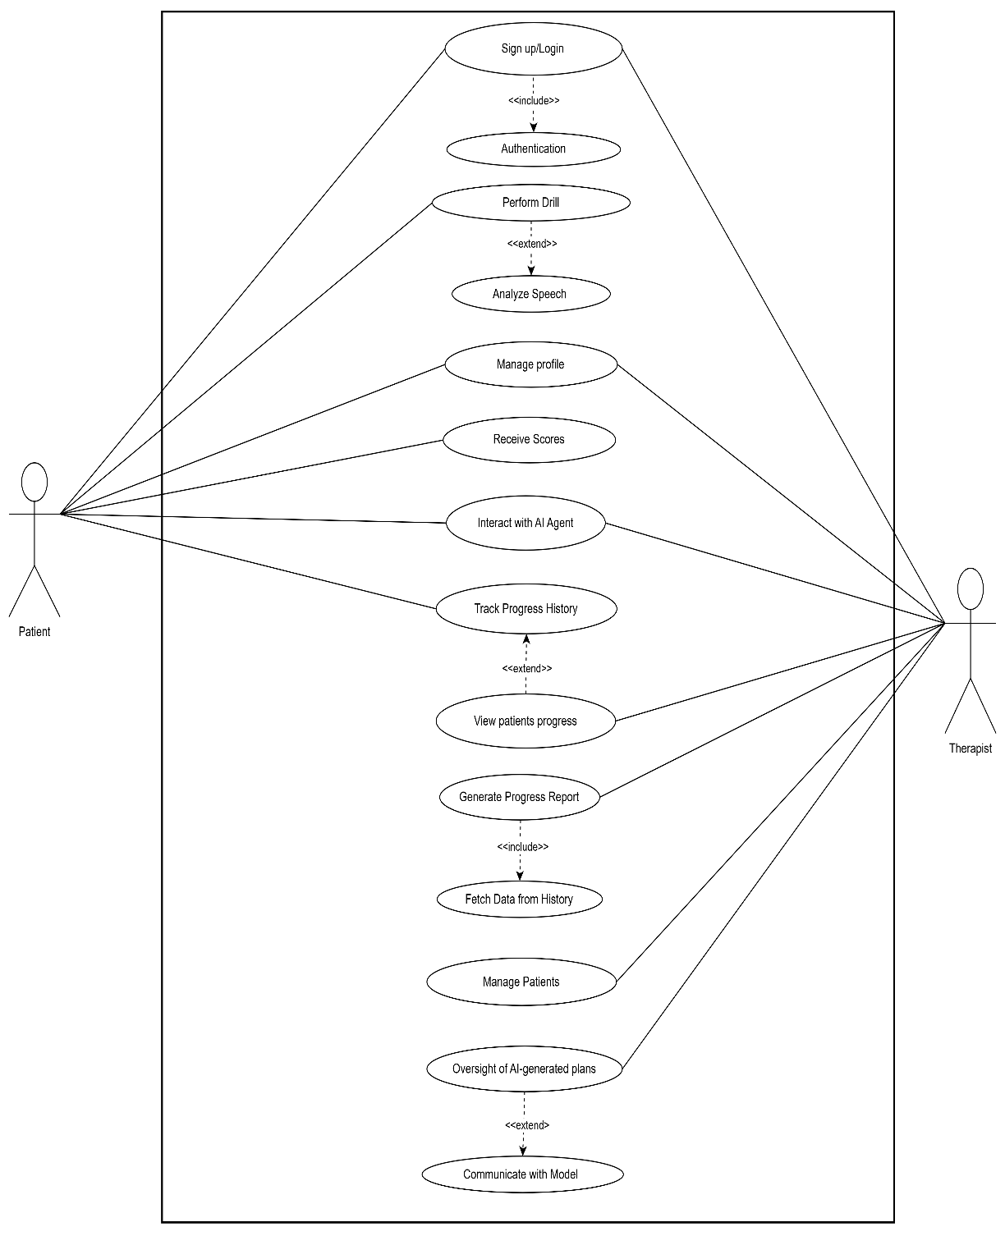
This section contains the Use Case Diagram for the project.

Figure 1. Use Case Diagram

5. High level Use Case

5.1. Signup/Login

Table 6. Use Case – Signup/Login
Use Case ID | UC-01
Use Case Name | Signup / Login
Type | Primary
Actor(s) | Patient, Therapist
Description | Allows a patient or therapist to create an account or log in to access their personalized dashboard and therapy features within the VocalAid application.

5.2. Authentication

Table 7.Use Case – Authentication
Use Case ID | UC-02
Use Case Name | Authentication
Type | Secondary
Actor(s) | System
Description | Validates credentials entered by the user to ensure secure access.

5.3. Perform Drill

Table 8.Use Case – Perform drill
Use Case ID | UC-03
Use Case Name | Perform Drill
Type | Primary
Actor(s) | Patient
Description | Enables the patient to perform assigned speech therapy drills through the VocalAid application. The system provides guided instructions, records audio responses, and analyzes speech for real-time performance feedback.

5.4. Analyze speech

Table 9. Use Case – Analyze speech
Use Case ID | UC-04
Use Case Name | Analyze Speech
Type | Secondary
Actor(s) | System
Description | Processes recorded speech to evaluate clarity, pronunciation, and fluency, generating instant feedback and scores.

5.5. Manage Profile

Table 10. Use Case – Manage Profile
Use Case ID | UC-05
Use Case Name | Manage Profile
Type | Secondary
Actor(s) | Patient, Therapist
Description | Enables users to update their personal details and preferences.

5.6. Receive Scores

Table 11. Use Case – Receive Scores
Use Case ID | UC-06
Use Case Name | Receive Scores
Type | Secondary
Actor(s) | Patient
Description | Shows real-time scores and feedback.

5.7. Interact with AI Agent

Table 12. Use Case – Interact with AI Agent
Use Case ID | UC-07
Use Case Name | Interact with AI Agent
Type | Primary
Actor(s) | Patient, Therapist
Description | Enables users to communicate with the AI agent for guidance, therapy support, or feedback.

5.8. Track Progress History

Table 13.Use Case – Track Progress History
Use Case ID | UC-08
Use Case Name | Track Progress History
Type | Primary
Actor(s) | Patient
Description | Allow patients to view their past session data, scores, and improvement trends.

5.9. View Patient Progress

Table 14. Use Case – View Patient Progress
Use Case ID | UC-09
Use Case Name | View Patient Progress
Type | Primary
Actor(s) | Therapist
Description | Lets therapists monitor patient progress through visual reports and  performance summaries.

5.10 Generate Progress Report

Table 15. Use Case – Generate Progress Report
Use Case ID | UC-10
Use Case Name | Generate Progress Report
Type | Secondary
Actor(s) | System
Description | Creates detailed reports based on patient performance and therapy sessions.

5.11. Fetch Data from History

Table 16. Use Case – Fetch Data from History
Use Case ID | UC-11
Use Case Name | Fetch Data from History
Type | Secondary
Actor(s) | System
Description | Retrieves stored therapy data and session records for analysis or report generation.

5.12. Manage Patients

Table 17. Use Case – Manage Patients
Use Case ID | UC-12
Use Case Name | Manage Patients
Type | Primary
Actor(s) | Therapist
Description | Allow therapists to add, view, or update patients and assign therapy tasks.

5.13. Oversight of AI Generated Plans

Table 18. Use Case – Oversight of AI Generated Plans
Use Case ID | UC-13
Use Case Name | Oversight Of AI Generated Plans
Type | Secondary
Actor(s) | Therapist
Description | Enables therapists to review, modify, and approve AI generated therapy recommendations.

5.14. Communicate with Model

Table 19. Use Case – Communicate with Model
Use Case ID | UC-14
Use Case Name | Communicate with Model
Type | Secondary
Actor(s) | System
Description | Allows the system to send and receive data from the AI model  for processing and feedback generation.

6. Expanded Use Case
This section explains the Expanded Use Cases for the project.

6.1. Perform Drills
Address Alerts Use Case is discussed below:

Table 20. Expanded Use Case – Perform Drills
Field | Details
Use Case ID | UC-03
Use Case Name | Perform drills
Actor | Patient
Description | This use case describes how a patient interacts with the system to perform speech therapy drills assigned by the AI system or therapist.
Precondition | The patient must be logged in and have an assigned drill session.
Normal Flow | - Patient logs into the mobile app.  - Patient navigates to daily drills.  - The system presents personalized speech exercises based on previous  performance.  - Patient records responses for each exercise.  - The system analyzes the audio input and evaluates pronunciation accuracy.  - Real-time feedback and correction tips are displayed to the patient.  - The system stores the performance data in the user profile.
Alternative Flows | If the patient skips or cannot complete a drill, the system reschedules it and notifies the therapist.
Post condition | Drill completion status, scores, and recorded audio are stored in the patient’s progress history.

6.2. Interact With AI Agent
View Data Summary Use Case is discussed below:

Table 21. Expanded Use Case – View Data Summary
Field | Details
Use Case ID | UC-07
Use Case Name | Interact with AI agent
Actor | Therapist, Patient
Description | This use case describes how the user interacts with the integrated AI agent for therapy support, progress queries, and information retrieval.
Precondition | The user must have an active session and microphone access enabled.
Basic Flow | - The user opens the AI Assistant section.  - The AI agent greets and provides therapy-related options (e.g.,  progress update, guidance, or motivation).  - The user asks a question (e.g., “How was my last session?”).  - The AI analyzes historical data and responds with relevant  summaries.  - The AI may suggest new exercises or improvement tips.  - The conversation history is stored for future context.
Alternative Flows | If the AI agent cannot understand the query, it prompts for clarification or suggests pre-defined options.
Post condition | Interaction logs and generated recommendations are saved to the system for future reference.

6.3. Generate Progress Reports
Generate Report Use Case is discussed below:

Table 22. Expanded Use Case – Generate Reports
Field | Details
Use Case ID | UC-10
Use Case Name | Generate Progress Reports
Actor | Therapist
Description | This use case describes how a therapist can generate progress reports based on the patient’s recorded sessions and performance data.
Precondition | The patient must have completed at least one session. The therapist must be logged in with appropriate permission.
Basic Flow | - The therapist logs into the web dashboard.  - Therapist selects a patient profile.  - Therapist chooses the report generation option.  - The system fetches historical performance, scoring trends, and audio records.  - The system compiles a detailed report including graphs, progress scores, and AI analysis.  - The report is displayed and made downloadable in PDF format.
Alternative Flows | If no data is available for the selected date range, the system notifies the therapist.
Post condition | The generated report is stored in the database and can be accessed or exported for future reference.

7. Activity Diagram
This section contains the Activity Diagram for the project.

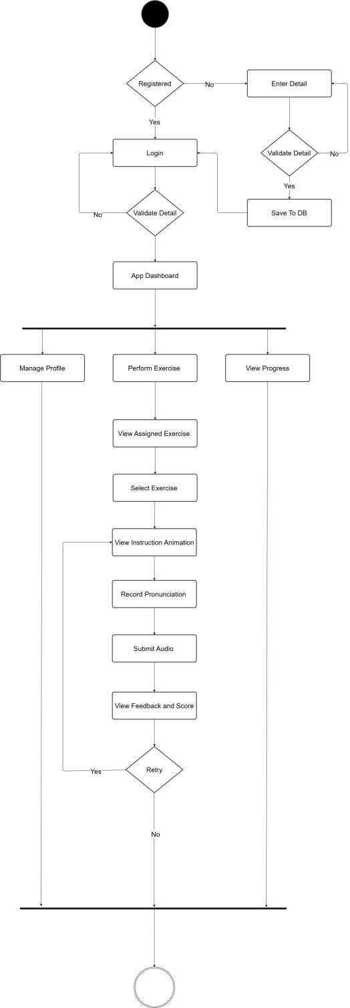
7.1. Patient Activity

Figure 2. Patient Activity Diagram

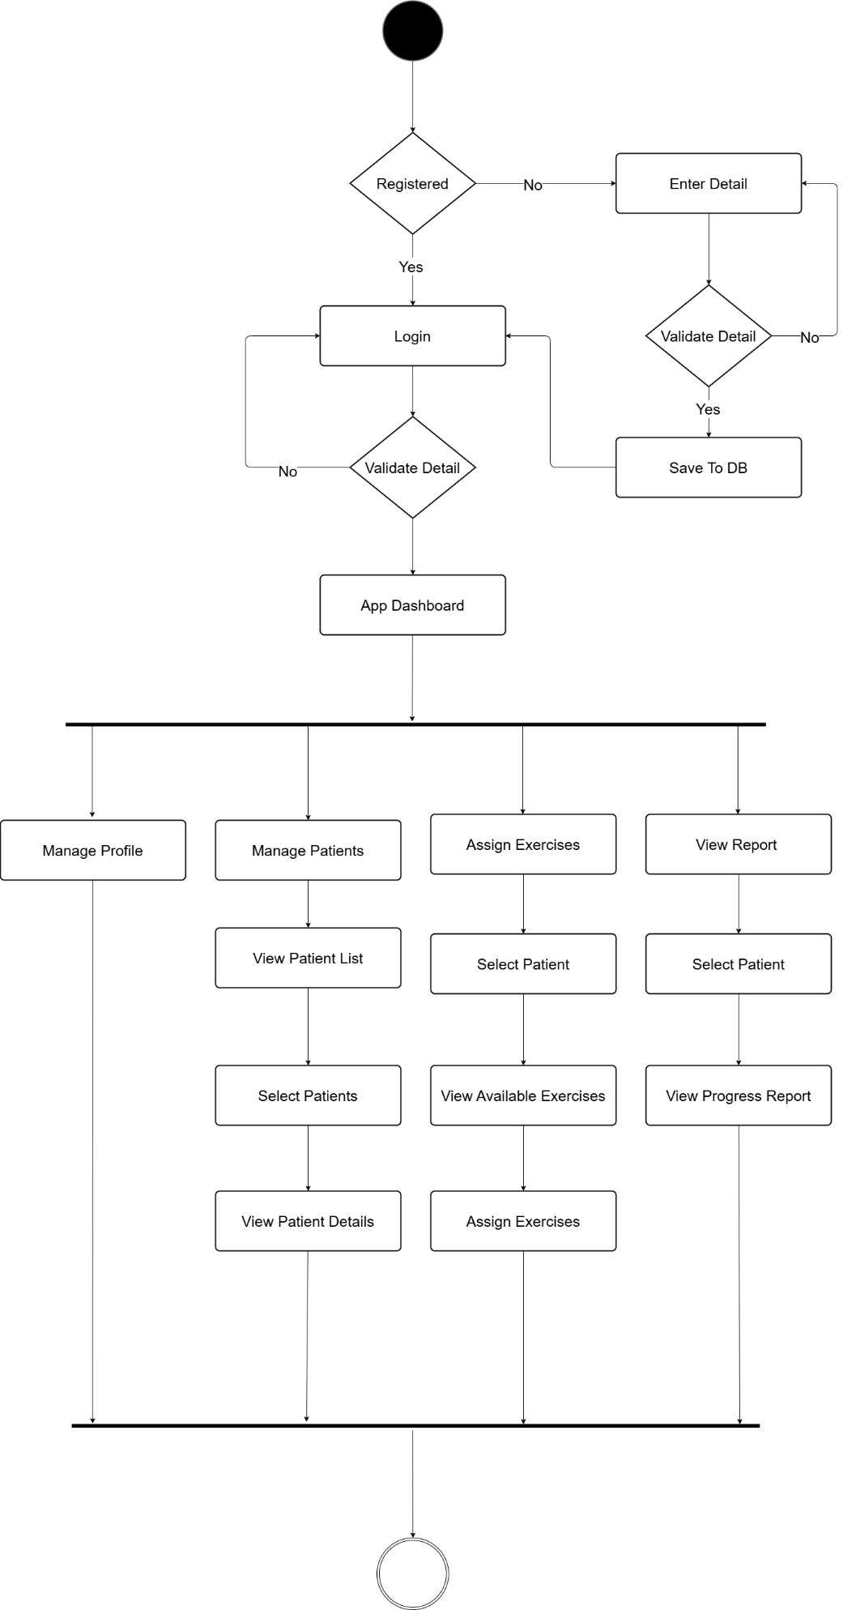
7.2. Therapist Activity

Figure 3. Therapist Activity Diagram

8. System Sequence Diagram
This section contains the System Sequence Diagram for the project.

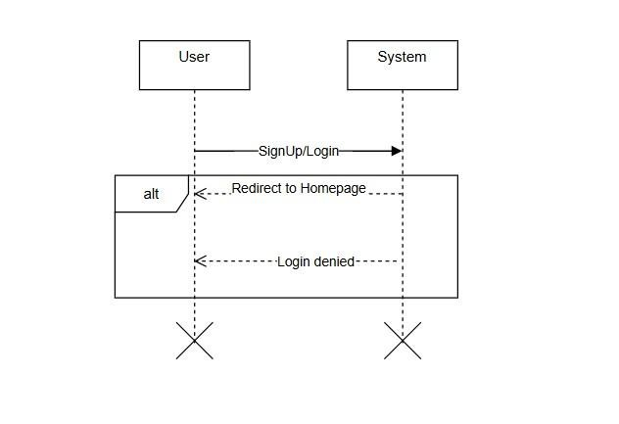
8.1 SignUp/Login
Figure 4. Signup - System Sequence Diagram

8.2 Profile
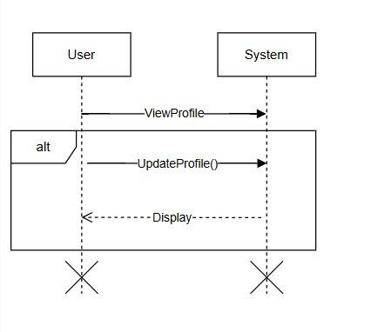
Figure 5. Profile - System Sequence Diagram

8.3 Patient

8.3.1 Perform Drills
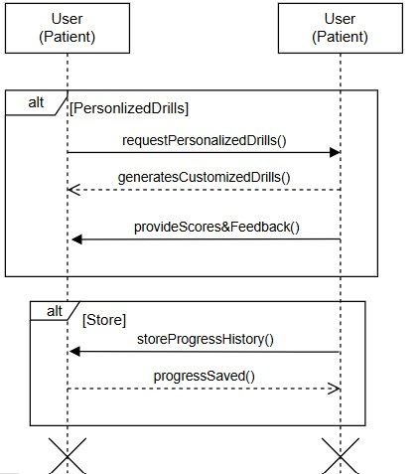

[Personalized Drills]

Figure 6. Perform Drills- System Sequence Diagram

8.3.2 Speech Analysis

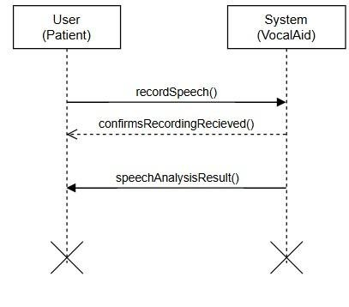
Figure 7. Speech Analysis- System Sequence Diagram

8.3.3 AI Agent
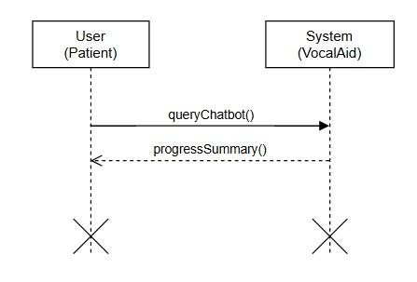
Figure 8. AI Agent - System Sequence Diagram

8.4 Therapist
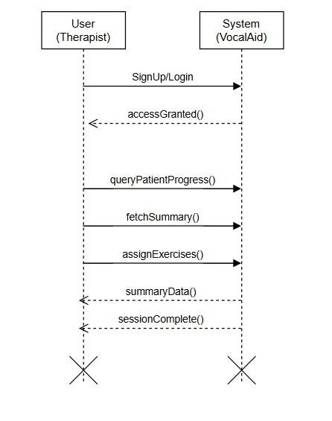
Figure 9. Therapist - System Sequence Diagram

9. Data Flow Diagram
This section contains the Data Flow Diagrams for the project.

9.1. Data Flow Diagram Level 0
Level 0 Data flow Diagram is shared below:
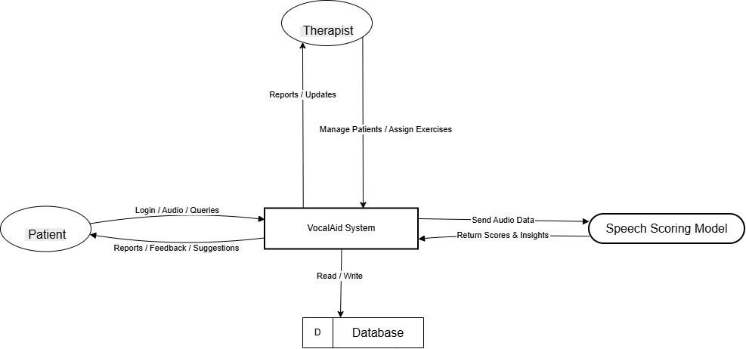

Figure 10. Data Flow Diagram Level 0

9.2. Data Flow Diagram Level 1
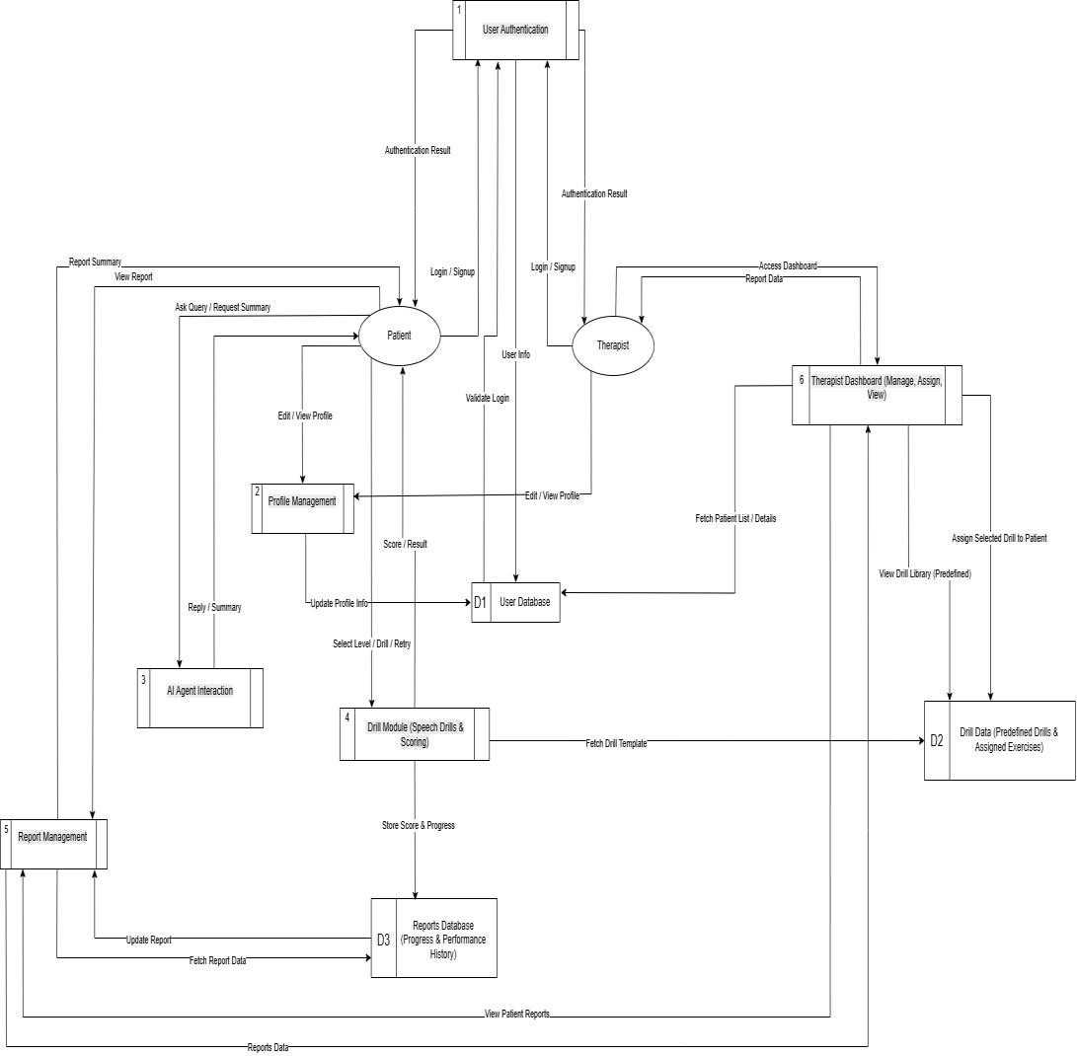
Level 1 Data flow Diagram is shared below:

Figure 11. Data Flow Diagram Level 1

9.3. Data Flow Diagram Level 2
Level 2 Data flow Diagram is shared below:
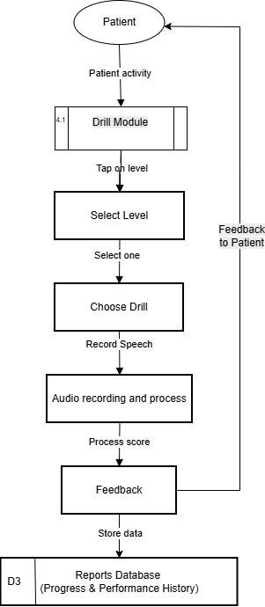

Figure 12. Data Flow Diagram Level 2

10. Domain Model Diagram
This section contains the Domain Model Diagram for the project.

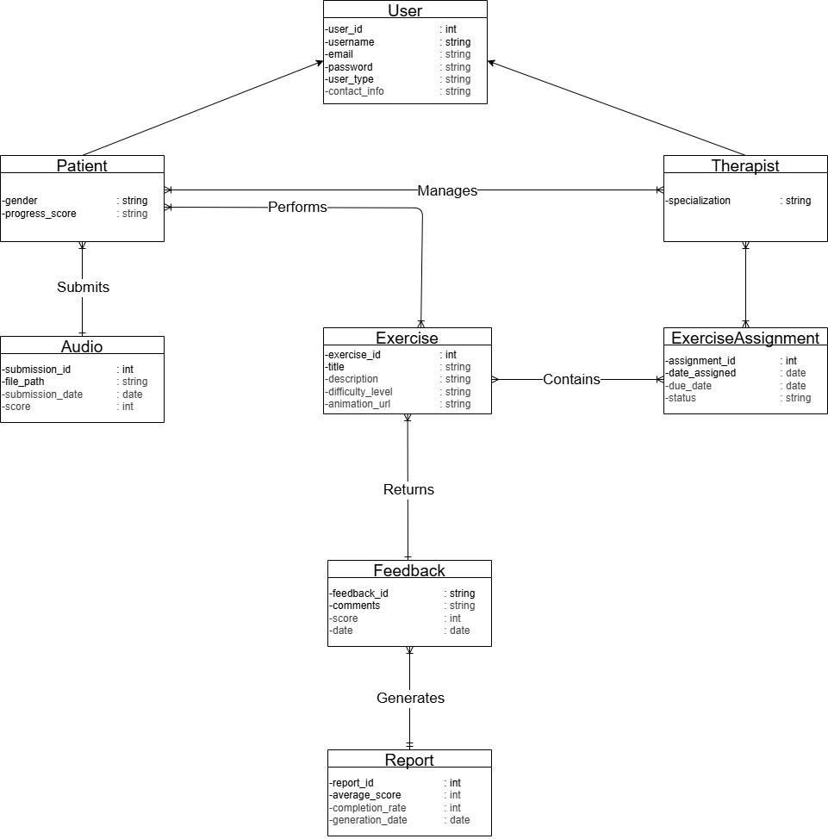

Figure 13. Domain Model Diagram

11. Component Diagram
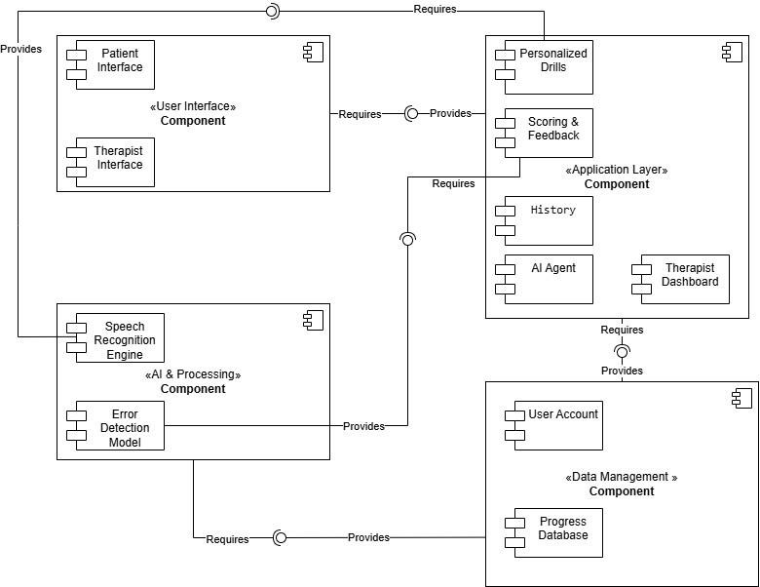
This section contains the Component Diagram for the project.

Figure 14. Component Diagram

12. Package Diagram

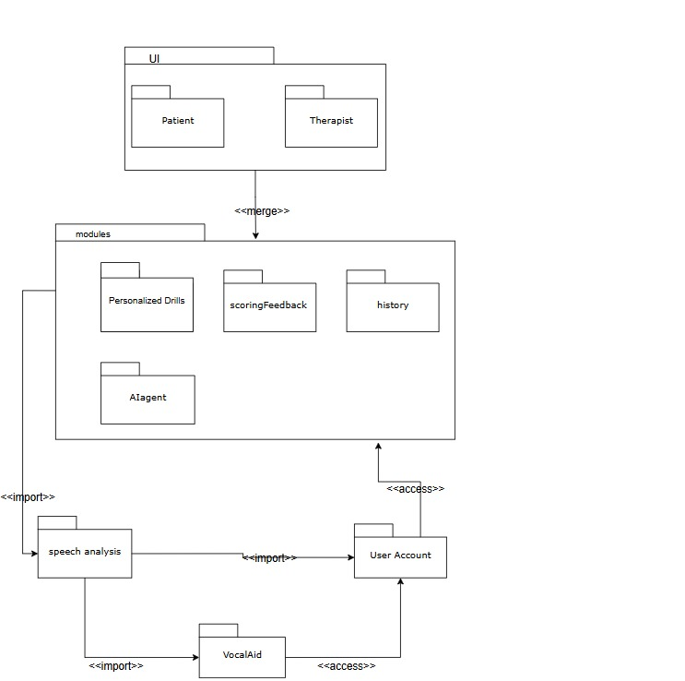
This section contains the Package Diagram for the project.

Figure 15. Package Diagram

13. Database Schema Diagram

13.1 Patient
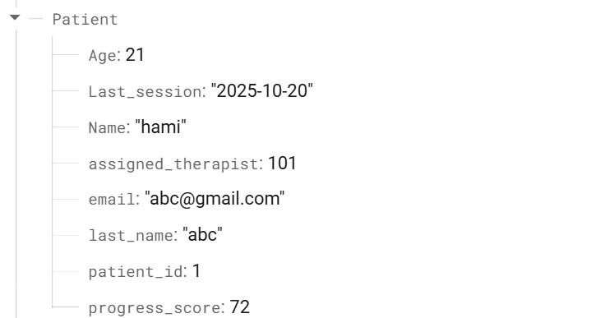
Figure 16. Patient - Database Schema Diagram

13.2 Therapist
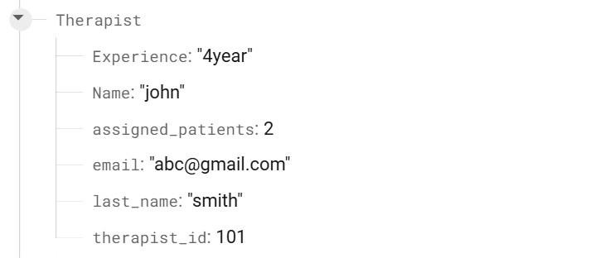
Figure 17. Therapist - Database Schema Diagram

13.3 Session
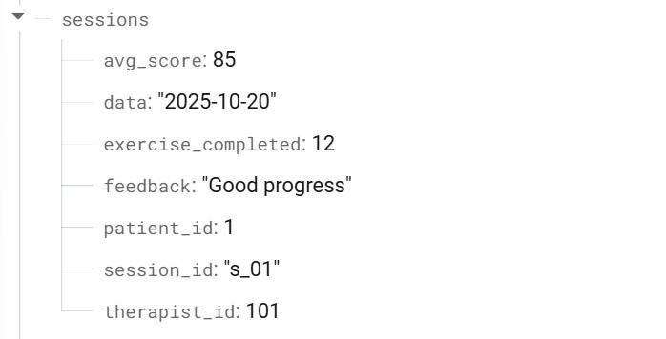
Figure 18. Session- Database Schema Diagram

13.4 Speech Drills

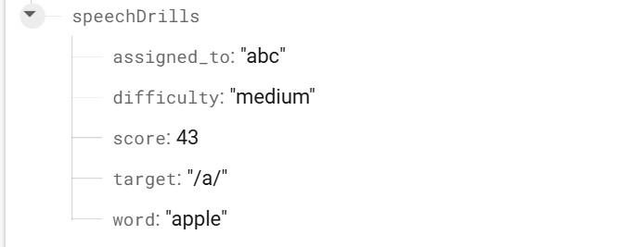
Figure 19. Speech Drills - Database Schema Diagram

13.5 Report

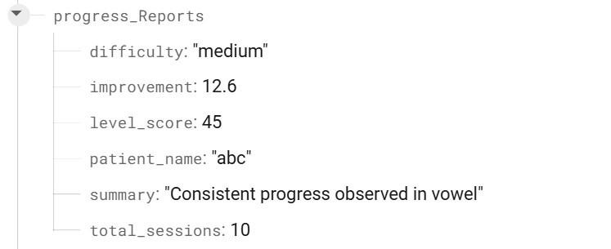

Figure 20. Report - Database Schema Diagram

13.6 AI Agent

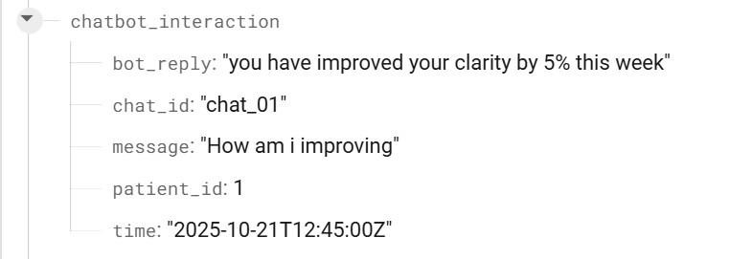
Figure 21. AI Agent - Database Schema Diagram

14. High Level Diagram
This section contains the High-Level Diagram for the project.
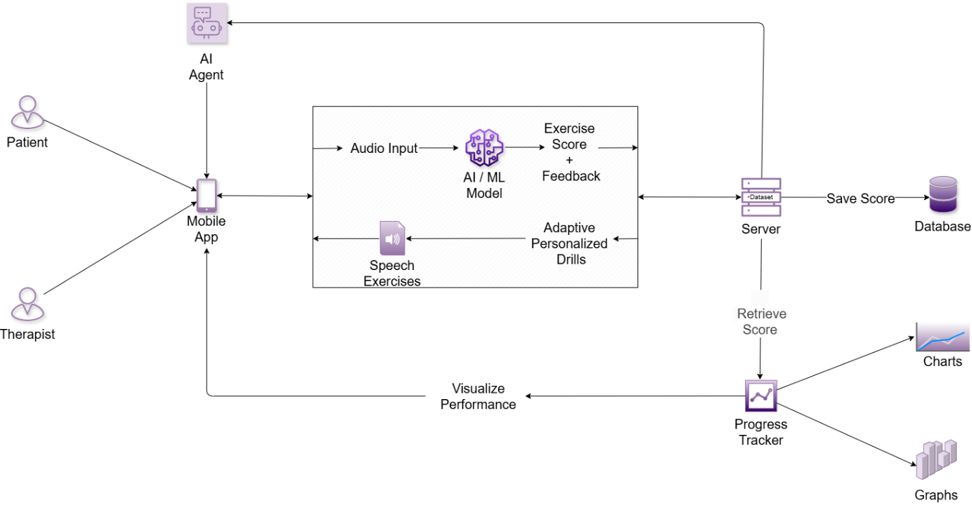

Figure 22. High Level Diagram

15. Manual Test Cases
Test Case ID | Feature | Description | Preconditions | Steps | Expected Result | Status Pass/Fail
TC001 | User Registration | Verify therapist registration. | User not logged in | - Go to register  - Select therapist  - Enter valid details  - Submit | Therapist account created | Pass
TC002 | User Registration | Verify patient registration with therapist code. | User not logged in | - Go to register  - Select patient  - Enter valid details  - Enter therapist code  - Submit | Request sent / pending screen shown | Pass
TC003 | Login | Verify therapist login with correct credentials. | Therapist account exists | - Go to login  - Enter valid credentials  - Submit | Therapist home opens | Pass
TC004 | Login | Verify patient login with accepted therapist link. | Patients already accepted | - Go to login  - Enter valid credentials  - Submit | Patient home opens | Pass
TC005 | Login | Verify invalid login credentials. | Account exists | - Go to login  - Enter wrong password  - Submit | Error message shown | Pass
TC006 | Therapist Code | Verify invalid therapist code entry. | Patient not linked to therapist | - Open code screen  - Enter invalid code  - Submit | Error shown / no link created | Pass
TC007 | Pending Status | Verify patient pending screen after request. | Patient request not accepted | - Log in as patient  - Check status | Pending screen displayed | Pass
TC008 | Patient Home | Verify dashboard navigation. | Patient logged in | - Open drawer  - Select profile / games / chat | Correct screen opens | Pass
TC009 | Therapist Home | Verify therapist dashboard navigation. | Therapist logged in | - Open drawer  - Select profile / patients / logout | Correct screen opens | Pass
TC010 | Chat | Verify patients can send messages to therapist. | Patient linked to therapist | - Open chat  - Type message  - Send | Message appears in chat | Pass
TC011 | Requests | Verify therapists can accept patient request. | Patient request exists | 1. Open requests  2. Tap accept | Patient status updated | Pass
TC012 | Games | Verify games screen opens from patient home. | Patient logged in | - Open games  - Launch memory match / word scramble | Game screen opens | Pass
TC013 | Profile | Verify profile update saves correctly. | User logged in | - Open profile  - Edit details  - Save | Updated data stored | Pass
TC014 | Logout | Verify logout clears session. | User logged in | 1. Tap logout | Returns to login screen | Pass

16. Automated Test Cases
Module: validation.test.js
Unit: Unit Test Suite for form validation and input checks
Test case ID | Input Values | Expected Output | Actual Output | Pass/Fail Status
V001 | Invalid email format | Throws validation error | Throws validation error | Passed
V002 | Empty registration fields | Throws validation error | Throws validation error | Passed
V003 | Empty therapist code | Throws validation error | Throws validation error | Passed
V004 | Empty login password | Throws validation error | Throws validation error | Passed

Module: auth.test.js
Unit: Unit Test Suite for authentication flow
Test case ID | Input Values | Expected Output | Actual Output | Pass/Fail Status
A001 | Valid therapist credentials | Therapist authenticated | Therapist authenticated | Passed
A002 | Valid patient credentials | Patient authenticated | Patient authenticated | Passed
A003 | Wrong password | Throws auth error | Throws auth error | Passed
A004 | Unregistered email | Throws auth error | Throws auth error | Passed
Module: roleRouting.test.js
Unit: Unit Test Suite for role-based screen routing
Test case ID | Input Values | Expected Output | Actual Output | Pass/Fail Status
R001 | Therapist user data | Routes to Therapist Home | Routes to Therapist Home | Passed
R002 | Accepted patient data | Routes to Patient Home | Routes to Patient Home | Passed
R003 | No therapist assigned | Routes to Enter Therapist Code | Routes to Enter Therapist Code | Passed
Module: chat.test.js
Unit: Unit Test Suite for chat operations
Test case ID | Input Values | Expected Output | Actual Output | Pass/Fail Status
C001 | Valid message text | Message stored and sent | Message stored and sent | Passed
C002 | Empty message | Message rejected | Message rejected | Passed

Module: profile.test.js
Unit: Unit Test Suite for profile updates
Test case ID | Input Values | Expected Output | Actual Output | Pass/Fail Status
P001 | Valid profile data | Profile updated | Profile updated | Passed
P002 | Empty required field | Throws validation error | Throws validation error | Passed
Module: personalization.test.js
Unit: Unit & Integration tests for personalized drills and adaptive behavior
Test case ID | Input Values | Expected Output | Actual Output | Pass/Fail Status
PR001 | Sufficient user history | Generates personalized drill set | Generates personalized drill set | Passed
PR002 | New user (cold start) | Generates default starter drill | Generates default starter drill | Passed
PR003 | Performance improvement over sessions | System increases drill difficulty | Increases difficulty | Passed
PR004 | Assigned drill visibility | Patient sees assigned drill in PersonalizedDrills | Assigned drill visible | Passed
PR006 | Persistence across sessions | Personalization persists across logins | Data persisted | Passed

17. References
[1] Diana, N. “UASpeech Dataset” Hugging Face.  https://huggingface.co/datasets/ngdiana/uaspeech | Available:
[2] Abner, H. “TORGO Database” Hugging Face. | Available:
https://huggingface.co/datasets/abnerh/TORGO-database
- Rudzicz, F., Namasivayam, A. K., & Wolff, T. (2012). The TORGO database of acoustic and articulatory speech from speakers with dysarthria. Language Resources and Evaluation, 46(4), 523–541.
- Xiong, H., & Rudzicz, F. (2013). Automatic recognition of dysarthric speech using deep neural networks. IEEE ICASSP, pp. 7492–7496.
- Vinotha, R., et al. (2024). Enhancing dysarthric speech recognition through SepFormer and hierarchical attention network models with multistage transfer learning. Scientific Reports.
Proposes a GAN-based front-end (S-SEGAN) combined with hierarchical attention Transformer/Conformer models, achieving word recognition accuracy up to ~84 % for dysarthric speech. Nature
- Ahileshwar, S. U. (2024). Personalized AI-Powered Therapy for Dysarthria (preprint). Presents an AI-driven therapy system for automated severity classification and tailored exercises in interactive form. techrxiv.org+1
- Mulfari, D. (2022). Deep learning applications in telerehabilitation speech therapy for dysarthric patients.
Advocates mobile ASR tools for language-independent speech therapy via telerehabilitation. ScienceDirect
- Srilakshmi, G., et al. (2025). Dysarthria Detection and Speech-to-Text Transcription Using Deep Learning and Audio Processing.
Uses Mel Frequency Logarithmic Spectrograms (MFLS) alongside DCNNs for robust dysarthria detection and transcription. J Neonatal Surg
- Alrajhi, T., Ykhlef, M., & Alsanad, A. (2024). Recent Advances in Dysarthric Speech Recognition: Approaches and Datasets.
Surveys research from 2018–2023, particularly on data augmentation, hybrid approaches, and dataset utilization in dysarthric ASR

